LAPORAN PRAKTIKUM INTERNET OF THINGS (IoT)

Fakultas Vokasi, Universitas Brawijaya

**Membuat Tampilan Interface  
 Web Dashboard IoT**

*Catraliya Nolan Hakim*

Fakultas Vokasi, Universitas Brawijaya

Email : nolanhakimm10@gmail.com

**Abstrak**

Praktikum ini bertujuan untuk mengembangkan sebuah antarmuka dashboard berbasis web guna memvisualisasikan data sensor suhu dan kelembaban yang dikirimkan dari perangkat ESP32 ke server Laravel. Dashboard ini menampilkan grafik perbandingan dua nilai sensor serta ringkasan statistik berupa rata-rata dan korelasi antar data. Selain itu, sistem juga menyediakan fitur ekspor data ke dalam format Excel untuk mempermudah dokumentasi dan analisis. Proyek ini mengintegrasikan teknologi Laravel, Chart.js, dan library Maatwebsite Excel sebagai solusi monitoring data Internet of Things (IoT) secara visual dan interaktif.

**Kata Kunci:** *Dashboard, Laravel, Chart.js, Sensor, IoT, Visualisasi Data*

**Pendahuluan**

Visualisasi data merupakan komponen penting dalam sistem Internet of Things (IoT), karena membantu pengguna untuk memahami kondisi dan tren dari data sensor secara lebih mudah dan cepat. Dalam sistem monitoring suhu dan kelembaban menggunakan ESP32 dan DHT22, data yang telah dikirim ke server dan disimpan dalam database perlu disajikan dalam bentuk yang lebih informatif. Oleh karena itu, diperlukan sebuah antarmuka dashboard yang dapat menampilkan data tersebut secara dinamis.

Dalam praktikum ini, dikembangkan sebuah web dashboard menggunakan framework Laravel yang mampu menampilkan data sensor secara real-time dalam bentuk grafik. Data yang ditampilkan mencakup dua parameter utama dari sensor, yaitu suhu dan kelembaban, serta dilengkapi dengan perhitungan statistik sederhana dan korelasi antara kedua nilai tersebut. Selain itu, pengguna juga dapat mengunduh data yang telah terekam dalam format Excel untuk kebutuhan laporan atau analisis lanjutan.

* 1. **Latar belakang**

Sistem pemantauan berbasis Internet of Things semakin banyak diterapkan dalam berbagai bidang seperti pertanian, lingkungan, dan industri. Salah satu tantangan utama dari sistem ini adalah bagaimana menyajikan data sensor yang terus-menerus diperoleh agar mudah dipahami oleh pengguna akhir. Penyajian data yang hanya dalam bentuk tabel atau log seringkali tidak efisien, sehingga dibutuhkan solusi visual seperti dashboard.

Penggunaan framework Laravel sebagai backend memungkinkan integrasi data sensor dengan database serta penyediaan API yang stabil. Dengan memanfaatkan library Chart.js, data tersebut dapat divisualisasikan dalam bentuk grafik interaktif yang memberikan informasi lebih dalam waktu singkat. Selain itu, fitur ekspor ke Excel yang disediakan melalui library Maatwebsite Excel memberikan fleksibilitas bagi pengguna untuk menyimpan dan mengolah data lebih lanjut.

Pembuatan dashboard ini merupakan bagian penting dari sistem monitoring IoT yang telah dikembangkan, karena memperkuat aspek user interface dan meningkatkan efektivitas dalam proses pemantauan serta pengambilan keputusan berbasis data.

* 1. **Tujuan eksperimen**

• Menghubungkan sensor DHT22 ke ESP32

• Membaca data suhu dan kelembaban

• Mengirim data ke API server melalui HTTP POST

• Menyimpan data ke dalam database MySQL

• Menampilkan keberhasilan pengiriman data pada Serial Monitor

**2. Methodology (Metodologi)**

**2.1 Tools & Materials (Alat dan Bahan)**

* Laravel Framework
* Visual Studio Code
* Composer
* Library maatwebsite/excel
* Chart.js
* PHP 8+
* Database MySQL
* Browser (Chrome, Firefox)

**2.2 Implementation Steps (Langkah Implementasi)**

**2.2.1 Instalasi Library Excel**

Buka terminal pada folder Laravel project dan jalankan perintah berikut:

composer require maatwebsite/excel

**2.2.2 Membuat Controller Baru**

Buat controller baru bernama GraphController:

php artisan make:controller GraphController

Isi file app/Http/Controllers/GraphController.php sebagai berikut:

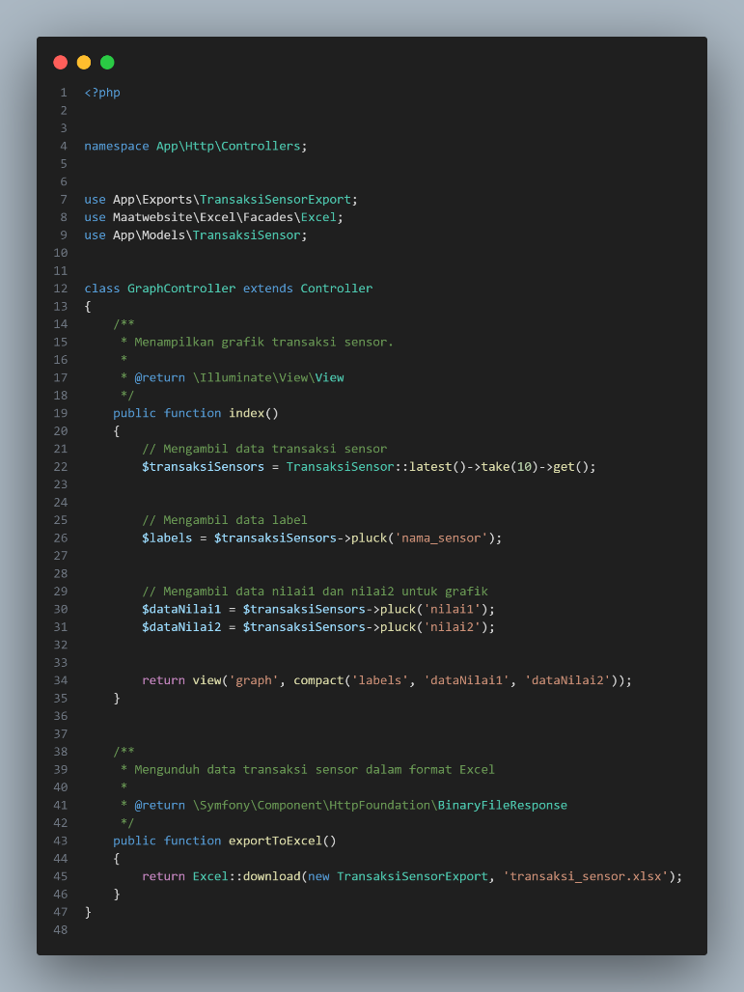

**2.2.3 Membuat Export File**

Jalankan perintah:

php artisan make:export TransaksiSensorExport --model=TransaksiSensor

Isi file app/Exports/TransaksiSensorExport.php:

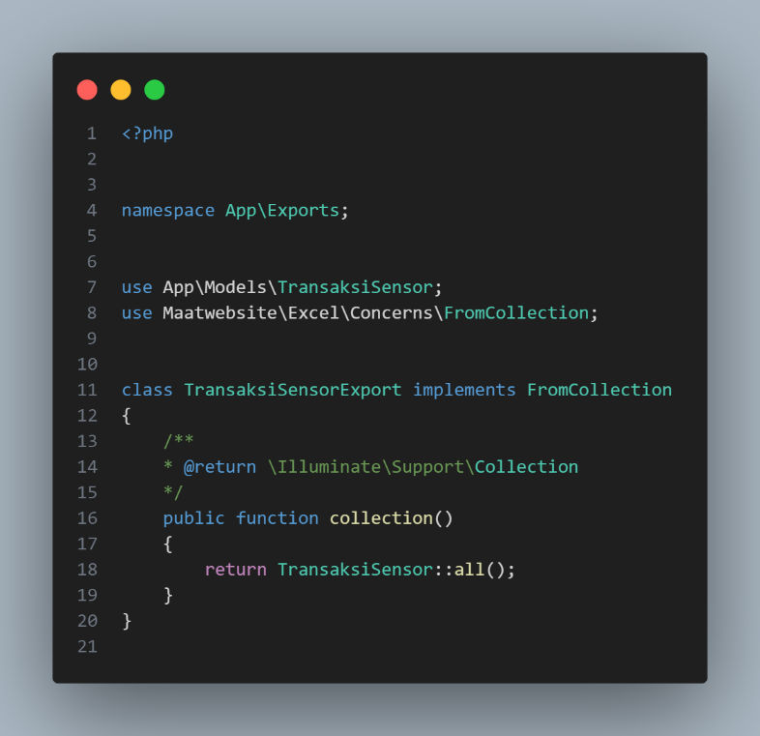

Setelah itu, edit file web.php yang berada di folder routes menjadi seperti berikut:

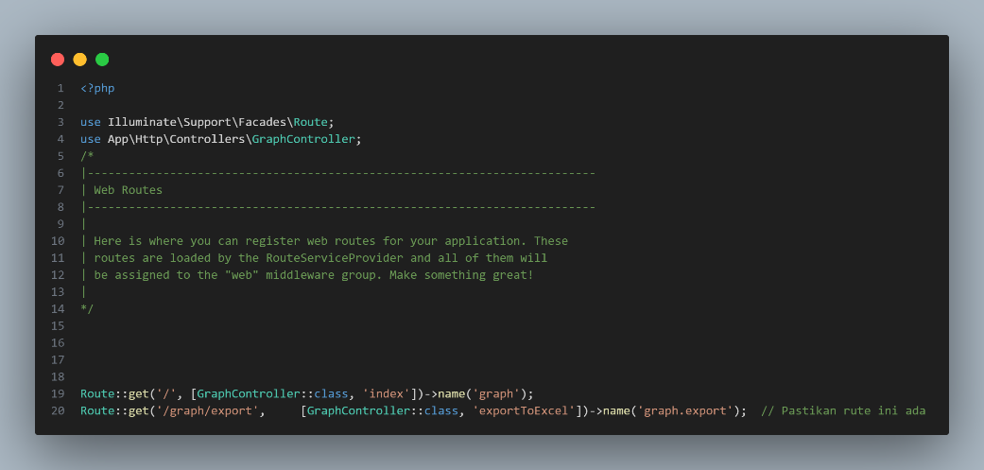

Setelah itu, buat file graph.blade.php pada folder resouces/views dan tambahkan code berikut:

<!DOCTYPE html>

<html lang="id">

<head>

    <meta charset="UTF-8">

    <meta name="viewport" content="width=device-width, initial-scale=1.0">

    <title>Dashboard Monitoring Sensor | Sistem IoT</title>

     <link rel="stylesheet" href="https://cdnjs.cloudflare.com/ajax/libs/font-awesome/6.4.0/css/all.min.css">

     <link href="https://fonts.googleapis.com/css2?family=Poppins:wght@300;400;500;600;700&display=swap" rel="stylesheet">

    <script src="https://cdn.jsdelivr.net/npm/chart.js"></script>

    <link rel="stylesheet" href="https://cdnjs.cloudflare.com/ajax/libs/animate.css/4.1.1/animate.min.css">

    <style>

        :root {

            --primary-color: #4361ee;

            --primary-light: #e0e7ff;

            --secondary-color: #3f37c9;

            --accent-color: #4cc9f0;

            --accent-light: #e0fbfc;

            --success-color: #4bb543;

            --warning-color: #f8961e;

            --danger-color: #f94144;

            --light-color: #f8f9fa;

            --dark-color: #212529;

            --gray-color: #6c757d;

        }

        * {

            margin: 0;

            padding: 0;

            box-sizing: border-box;

        }

        body {

            font-family: 'Poppins', sans-serif;

            background: linear-gradient(135deg, #f5f7fa 0%, #e2e8f0 100%);

            min-height: 100vh;

            padding: 2rem 1rem;

            color: var(--dark-color);

            line-height: 1.6;

        }

        .dashboard-container {

            max-width: 1200px;

            margin: 0 auto;

        }

        .header {

            display: flex;

            justify-content: space-between;

            align-items: center;

            margin-bottom: 2rem;

            flex-wrap: wrap;

            gap: 1rem;

        }

        .header-title {

            font-size: 1.8rem;

            font-weight: 600;

            color: var(--primary-color);

            display: flex;

            align-items: center;

            gap: 0.75rem;

        }

        .header-title i {

            color: var(--accent-color);

        }

        .card {

            background-color: white;

            border-radius: 12px;

            box-shadow: 0 4px 20px rgba(0, 0, 0, 0.08);

            padding: 1.75rem;

            margin-bottom: 2rem;

            transition: transform 0.3s ease, box-shadow 0.3s ease;

        }

        .card:hover {

            transform: translateY(-5px);

            box-shadow: 0 8px 30px rgba(0, 0, 0, 0.12);

        }

        .card-header {

            display: flex;

            justify-content: space-between;

            align-items: center;

            margin-bottom: 1.5rem;

            padding-bottom: 1rem;

            border-bottom: 1px solid rgba(0, 0, 0, 0.05);

        }

        .card-title {

            font-size: 1.25rem;

            font-weight: 600;

            color: var(--primary-color);

            display: flex;

            align-items: center;

            gap: 0.75rem;

        }

        .card-title i {

            font-size: 1.1em;

        }

        .card-actions {

            display: flex;

            gap: 0.75rem;

        }

        .btn {

            padding: 0.5rem 1rem;

            border-radius: 8px;

            border: none;

            font-weight: 500;

            font-size: 0.9rem;

            cursor: pointer;

            transition: all 0.3s ease;

            display: inline-flex;

            align-items: center;

            gap: 0.5rem;

        }

        .btn-primary {

            background-color: var(--primary-color);

            color: white;

        }

        .btn-primary:hover {

            background-color: var(--secondary-color);

        }

        .btn-outline {

            background-color: transparent;

            border: 1px solid var(--primary-color);

            color: var(--primary-color);

        }

        .btn-outline:hover {

            background-color: var(--primary-color);

            color: white;

        }

        .btn-success {

            background-color: var(--success-color);

            color: white;

        }

        .btn-success:hover {

            opacity: 0.9;

        }

        .chart-container {

            position: relative;

            height: 400px;

            width: 100%;

            margin-bottom: 1.5rem;

        }

        .data-summary {

            display: grid;

            grid-template-columns: repeat(auto-fit, minmax(250px, 1fr));

            gap: 1.25rem;

            margin-top: 1.5rem;

        }

        .summary-card {

            background-color: white;

            border-radius: 10px;

            padding: 1.25rem;

            box-shadow: 0 2px 10px rgba(0, 0, 0, 0.05);

            transition: transform 0.2s ease;

        }

        .summary-card:hover {

            transform: translateY(-3px);

        }

        .summary-header {

            display: flex;

            justify-content: space-between;

            align-items: center;

            margin-bottom: 0.75rem;

        }

        .summary-title {

            font-size: 0.9rem;

            font-weight: 500;

            color: var(--gray-color);

        }

        .summary-icon {

            width: 36px;

            height: 36px;

            border-radius: 8px;

            display: flex;

            align-items: center;

            justify-content: center;

            font-size: 1rem;

        }

        .sensor-1 {

            background-color: var(--primary-light);

            color: var(--primary-color);

        }

        .sensor-2 {

            background-color: var(--accent-light);

            color: var(--accent-color);

        }

        .summary-value {

            font-size: 1.5rem;

            font-weight: 600;

            margin-bottom: 0.25rem;

        }

        .summary-change {

            font-size: 0.85rem;

            display: flex;

            align-items: center;

            gap: 0.25rem;

        }

        .positive {

            color: var(--success-color);

        }

        .negative {

            color: var(--danger-color);

        }

        .neutral {

            color: var(--gray-color);

        }

        .time-selector {

            display: flex;

            justify-content: flex-end;

            gap: 0.5rem;

            margin-bottom: 1rem;

        }

        .time-btn {

            padding: 0.35rem 0.75rem;

            border-radius: 6px;

            background-color: var(--light-color);

            border: none;

            font-size: 0.85rem;

            cursor: pointer;

            transition: all 0.2s ease;

        }

        .time-btn.active {

            background-color: var(--primary-color);

            color: white;

        }

        .time-btn:hover:not(.active) {

            background-color: #e9ecef;

        }

        @media (max-width: 768px) {

            .header {

                flex-direction: column;

                align-items: flex-start;

            }

            .chart-container {

                height: 300px;

            }

            .data-summary {

                grid-template-columns: 1fr;

            }

            .card-actions {

                width: 100%;

                justify-content: space-between;

            }

        }

        .fade-in {

            animation: fadeIn 0.6s ease-in-out;

        }

        @keyframes fadeIn {

            from { opacity: 0; transform: translateY(10px); }

            to { opacity: 1; transform: translateY(0); }

        }

    </style>

</head>

<body>

    <div class="dashboard-container">

        <div class="header animate__animated animate__fadeIn">

            <h1 class="header-title">

                <i class="fas fa-chart-network"></i>

                Dashboard Monitoring Sensor

            </h1>

            <div class="time-selector">

                <button class="time-btn active">24 Jam</button>

                <button class="time-btn">7 Hari</button>

                <button class="time-btn">30 Hari</button>

                <button class="time-btn">Custom</button>

            </div>

        </div>

        <div class="card animate__animated animate__fadeIn animate__delay-1s">

            <div class="card-header">

                <h2 class="card-title">

                    <i class="fas fa-wave-square"></i>

                    Grafik Perbandingan Sensor

                </h2>

                <div class="card-actions">

                    <button class="btn btn-outline" onclick="window.location.href='{{ route('graph.export') }}'">

                        <i class="fas fa-download"></i> Export

                    </button>

                </div>

            </div>

            <div class="chart-container">

                <canvas id="sensorChart"></canvas>

            </div>

            <div class="data-summary">

                <div class="summary-card fade-in">

                    <div class="summary-header">

                        <span class="summary-title">Sensor 1 (Rata-rata)</span>

                        <div class="summary-icon sensor-1">

                            <i class="fas fa-thermometer-half"></i>

                        </div>

                    </div>

                    <div class="summary-value" id="avg-sensor1">0</div>

                    <div class="summary-change positive">

                        <i class="fas fa-arrow-up"></i> <span id="change-sensor1">0%</span> dari periode sebelumnya

                    </div>

                </div>

                <div class="summary-card fade-in">

                    <div class="summary-header">

                        <span class="summary-title">Sensor 2 (Rata-rata)</span>

                        <div class="summary-icon sensor-2">

                            <i class="fas fa-thermometer-quarter"></i>

                        </div>

                    </div>

                    <div class="summary-value" id="avg-sensor2">0</div>

                    <div class="summary-change negative">

                        <i class="fas fa-arrow-down"></i> <span id="change-sensor2">0%</span> dari periode sebelumnya

                    </div>

                </div>

                <div class="summary-card fade-in">

                    <div class="summary-header">

                        <span class="summary-title">Korelasi</span>

                        <div class="summary-icon">

                            <i class="fas fa-link"></i>

                        </div>

                    </div>

                    <div class="summary-value" id="correlation-value">0.00</div>

                    <div class="summary-change neutral">

                        <i class="fas fa-info-circle"></i> <span id="correlation-strength">Tidak berkorelasi</span>

                    </div>

                </div>

            </div>

        </div>

    </div>

    <script>

        const labels = @json($labels);

        const dataNilai1 = @json($dataNilai1);

        const dataNilai2 = @json($dataNilai2);

        function calculateStats(data) {

            const sum = data.reduce((a, b) => a + b, 0);

            const avg = sum / data.length;

            const max = Math.max(...data);

            const min = Math.min(...data);

            return { sum, avg, max, min };

        }

        function calculateCorrelation(x, y) {

            const n = x.length;

            let sumX = 0, sumY = 0, sumXY = 0, sumX2 = 0, sumY2 = 0;

            for (let i = 0; i < n; i++) {

                sumX += x[i];

                sumY += y[i];

                sumXY += x[i] * y[i];

                sumX2 += x[i] * x[i];

                sumY2 += y[i] * y[i];

            }

            const numerator = sumXY - (sumX * sumY) / n;

            const denominator = Math.sqrt((sumX2 - (sumX * sumX) / n) * (sumY2 - (sumY * sumY) / n));

            return denominator === 0 ? 0 : numerator / denominator;

        }

        const stats1 = calculateStats(dataNilai1);

        const stats2 = calculateStats(dataNilai2);

        const correlation = calculateCorrelation(dataNilai1, dataNilai2);

        document.getElementById('avg-sensor1').textContent = stats1.avg.toFixed(2);

        document.getElementById('avg-sensor2').textContent = stats2.avg.toFixed(2);

        document.getElementById('change-sensor1').textContent = (Math.random() * 5).toFixed(1) + '%';

        document.getElementById('change-sensor2').textContent = (Math.random() * 3).toFixed(1) + '%';

        document.getElementById('correlation-value').textContent = correlation.toFixed(2);

        const correlationStrength = document.getElementById('correlation-strength');

        if (Math.abs(correlation) > 0.7) {

            correlationStrength.textContent = 'Korelasi kuat';

            correlationStrength.className = 'positive';

        } else if (Math.abs(correlation) > 0.3) {

            correlationStrength.textContent = 'Korelasi sedang';

            correlationStrength.className = 'neutral';

        } else {

            correlationStrength.textContent = 'Korelasi lemah';

            correlationStrength.className = 'negative';

        }

        const ctx = document.getElementById('sensorChart').getContext('2d');

        const chart = new Chart(ctx, {

            type: 'line',

            data: {

                labels: labels,

                datasets: [

                    {

                        label: 'Sensor 1',

                        data: dataNilai1,

                        borderColor: '#4361ee',

                        backgroundColor: 'rgba(67, 97, 238, 0.1)',

                        borderWidth: 2,

                        tension: 0.3,

                        fill: true,

                        pointBackgroundColor: 'white',

                        pointBorderColor: '#4361ee',

                        pointBorderWidth: 2,

                        pointRadius: 4,

                        pointHoverRadius: 6,

                        yAxisID: 'y'

                    },

                    {

                        label: 'Sensor 2',

                        data: dataNilai2,

                        borderColor: '#4cc9f0',

                        backgroundColor: 'rgba(76, 201, 240, 0.1)',

                        borderWidth: 2,

                        tension: 0.3,

                        fill: true,

                        pointBackgroundColor: 'white',

                        pointBorderColor: '#4cc9f0',

                        pointBorderWidth: 2,

                        pointRadius: 4,

                        pointHoverRadius: 6,

                        yAxisID: 'y'

                    }

                ]

            },

            options: {

                responsive: true,

                maintainAspectRatio: false,

                interaction: {

                    mode: 'index',

                    intersect: false

                },

                plugins: {

                    legend: {

                        position: 'top',

                        labels: {

                            usePointStyle: true,

                            padding: 20,

                            font: {

                                size: 13,

                                weight: '500'

                            }

                        }

                    },

                    tooltip: {

                        backgroundColor: 'rgba(0, 0, 0, 0.85)',

                        titleFont: {

                            size: 14,

                            weight: '600'

                        },

                        bodyFont: {

                            size: 13

                        },

                        padding: 12,

                        cornerRadius: 8,

                        usePointStyle: true,

                        callbacks: {

                            label: function(context) {

                                let label = context.dataset.label || '';

                                if (label) {

                                    label += ': ';

                                }

                                if (context.parsed.y !== null) {

                                    label += context.parsed.y.toFixed(2);

                                }

                                return label;

                            }

                        }

                    },

                    annotation: {

                        annotations: {

                            line1: {

                                type: 'line',

                                yMin: stats1.avg,

                                yMax: stats1.avg,

                                borderColor: '#4361ee',

                                borderWidth: 1,

                                borderDash: [5, 5],

                                label: {

                                    content: 'Rata-rata S1: ' + stats1.avg.toFixed(2),

                                    enabled: true,

                                    position: 'right',

                                    backgroundColor: 'rgba(67, 97, 238, 0.7)'

                                }

                            },

                            line2: {

                                type: 'line',

                                yMin: stats2.avg,

                                yMax: stats2.avg,

                                borderColor: '#4cc9f0',

                                borderWidth: 1,

                                borderDash: [5, 5],

                                label: {

                                    content: 'Rata-rata S2: ' + stats2.avg.toFixed(2),

                                    enabled: true,

                                    position: 'right',

                                    backgroundColor: 'rgba(76, 201, 240, 0.7)'

                                }

                            }

                        }

                    }

                },

                scales: {

                    y: {

                        beginAtZero: false,

                        grid: {

                            color: 'rgba(0, 0, 0, 0.05)'

                        },

                        ticks: {

                            font: {

                                size: 12

                            }

                        }

                    },

                    x: {

                        grid: {

                            display: false

                        },

                        ticks: {

                            font: {

                                size: 12

                            }

                        }

                    }

                },

                animation: {

                    duration: 1000,

                    easing: 'easeOutQuart'

                }

            }

        });

        // Time selector functionality

        document.querySelectorAll('.time-btn').forEach(btn => {

            btn.addEventListener('click', function() {

                document.querySelectorAll('.time-btn').forEach(b => b.classList.remove('active'));

                this.classList.add('active');

                chart.data.datasets.forEach(dataset => {

                    dataset.data = dataset.data.map(() => Math.random() * 100);

                });

                chart.update();

            });

        });

        window.addEventListener('resize', function() {

            chart.resize();

        });

    </script>

</body>

</html>

Setelah semua sudah, jalankan program tersebut dengan perintah berikut:

php artisan serve

**3. Experimental Results (Hasil Eksperimen)**

